Synthetic Emotional Affect: Visual Language Models as Emotional Evaluators for Physical Environments
Anonymous

Abstract
Recent advances in Vision Language Models (VLMs) have prompted growing interest in their use as scalable proxies for human affective evaluation of urban and architectural environments. However, existing studies largely rely on non-immersive 2D imagery, inconsistently defined affective dimensions, and environmental appraisal measures rather than subjective emotional responses. Consequently, the extent to which VLMs reproduce human affect under ecologically valid immersive conditions remains unclear.
This study evaluates VLMs as affective proxies within immersive Virtual Reality (VR) environments. Human participants assessed a curated set of urban scenes using the Positive and Negative Affect Schedule (PANAS), while multiple state-of-the-art VLMs generated corresponding affective ratings for the same stimuli.
Across models, VLMs achieved moderate-to-high agreement with human judgments on aggregate affective ratings and preserved substantial similarity in the representational structure of affective responses (RSA). However, this alignment was not uniform: Bland–Altman and item-level analyses revealed systematic calibration asymmetries, characterized by compression of negative affect intensity and localized errors in high-salience descriptors related to threat and hostility. Together, these findings indicate that VLMs reproduce the relational geometry of human affective experience while diverging in the scaling of affect intensity.
These results suggest that contemporary VLMs are well-suited for comparative and exploratory assessment of architectural environments, but remain limited for precise estimation of absolute emotional intensity, particularly for negative affect. By integrating immersive VR experimentation with psychometrically grounded evaluation and multi-level model analysis, this work advances the methodological foundations for AI-assisted affective assessment in architecture and urban design.
Keywords: Vision Language Models (VLMs), Virtual Reality (VR), Positive and Negative Affect Schedule (PANAS), Environmental Psychology, Affective Computing

Introduction
The design of urban and architectural environments fundamentally shapes the psychological and physiological well-being of their inhabitants (Qin et al., 2021; Van Der Wal et al., 2021). The emotional impact, or affect, evoked by the built environment is recognized as a critical, non-negotiable factor in modern planning and renovation projects (Aghabozorgi et al., 2024; Ma et al., 2024). Therefore, optimizing the positive emotional resonance is principal for creating living environments that support human flourishing and mental health.

However, accurately quantifying the nuanced, large-scale human emotional response poses significant methodological challenges. Traditional assessment has long relied on labor-intensive, costly methods, primarily subjective human self-report surveys, like questionnaires, or in-depth interviews (Scott & Benson, 2002; Weinreb & Rofè, 2013). While essential for spatial design and management, these methods are not scalable at the urban scale.

This bottleneck has driven the search for computational, automated, objective solutions. The rapid emergence of street-view images (SVIs), combined with crowdsourced survey methods, has created new opportunities for big data gathering (He & Li, 2021). A common example is MIT's Place Pulse projects, consisting of extensive urban image data across six attributes: safe, lively, boring, wealthy, depressing, and beautiful (Salesses et al., 2013). These datasets have supported the creation of models that predict these subjective attributes of urban environments using deep learning-based computer vision models (Ogawa et al., 2024; Zhao et al., 2024). This approach generally requires extensive human annotation and dedicated supervised training pipelines.

The emergence of Visual Language Models (VLMs) offers a highly scalable, automated paradigm shift, positioning these models as viable substitutes for time-intensive human involvement in affect rating. Prior work has demonstrated that LLMs can reproduce aggregate survey responses across a range of psychological measures (Bommasani et al., 2021; Argyle et al., 2023), perform above chance on emotion recognition tasks (Amin et al., 2023), and produce self-report-style outputs consistent with human personality profiles (Jiang et al., 2024).

Indeed, recent studies have explored the use of VLMs for affective assessment of urban spaces. Guz et al. (2025) demonstrated that affective ratings generated by GPT-4o for visual stimuli significantly correlate with human evaluations, suggesting partial alignment between model-based and human affective assessments. Ma and Quan (2026) showed that VLM-based evaluations of psychological restorative qualities outperform several conventional techniques, with further improvements achieved by incorporating domain-specific prior knowledge through targeted fine-tuning. Moreover, the explanatory textual outputs generated by the models enabled additional analytical interpretation and practical urban planning insights. Similarly, Yao et al. (2026) reported moderate-to-high consistency between VLM-based evaluations and human judgments of urban street-scene perception. Importantly, they showed how the textual rationales generated by the models can be translated into actionable planning language that identifies and prioritizes urban interventions.

While these automated approaches are promising, previous research suffers from several critical shortcomings and limited scopes. First, the various chosen emotional dimensions often lack robust psychological or theoretical justification, leading to arbitrary and inconsistent measurement scales (Rui et al., 2025). Second, studies typically focus on rating the "objective" built environment (e.g., assessing how "boring" a scene is) rather than on capturing participants' subjective emotional states. This fails to measure how much the individual feels bored while immersed in the scene, conflating environmental attributes with personal affect. Third, a significant drawback is that previous human participants were asked to rate 2D images presented on a screen via a non-immersive online application. Human judgment of 2D static images is fundamentally different from the rich, immersive experience of being inside a 3D scene (Kuhne et al., 2023). Finally, previous studies rely on data from car-perspective street panoramas, which fail to capture the human experience when walking the sidewalks or experiencing architectural spaces. Furthermore, aggregating these similar street-view images often leads to an averaging effect in VLM assessment, overlooking the extreme or distinct places that elicit the most diverse and meaningful emotional responses.

In this paper, we present a more ecologically grounded evaluation of VLMs as affective proxies for built environments. We compare affective ratings produced by multiple VLMs with responses from human participants exposed to spatial scenes in immersive virtual reality (VR). Multiple experimental studies directly comparing VR and 2D presentation formats have shown that immersive VR generally produces stronger presence, affective engagement, autonomic activation, and neural responses (Chirico et al., 2017; Al Alam et al., 2021; Kuhne et al., 2023). Compared to 2D displays, VR environments are often associated with higher reported emotional intensity, elevated heart rate and skin conductance responses, and more pronounced neural activation patterns, including larger ERP amplitudes, stronger alpha/beta-band effects, and enhanced amygdala responses for some emotional stimuli (Dores et al., 2014; Schubring et al., 2020; Tian et al., 2021; Xie et al., 2022). Accordingly, immersive VR may provide a more behaviorally and affectively representative measure of human emotional experience in urban environments than static 2D imagery.

Unlike prior studies based primarily on street imagery, our experimental design employs a deliberately curated set of urban scenes captured from human viewpoints intended to maximize perceptual diversity and affective distinctiveness.

Human affective responses were assessed using the Positive and Negative Affect Schedule (PANAS), a widely validated instrument for measuring two orthogonal dimensions, Positive Affect (PA) and Negative Affect (NA), each comprising ten items rated on a 1–5 scale (Watson et al., 1988). Its well-characterized factor structure and sensitivity to experimental manipulations make it an ideal criterion instrument for evaluating whether VLMs reproduce both the magnitude and structure of affective responses.

Collectively, these methodological choices were designed to address the limitations of prior image-based studies, particularly the absence of immersive experience, reliance on vehicle-centered viewpoints, and the conflation of perceptual appraisal with subjective affective response.
Our contribution is therefore twofold. First, we provide a grounded benchmark for evaluating VLMs as affective proxies in built-environment research by comparing their outputs with VR-based human affective responses. Second, we assess and compare multiple VLMs systematically for their relative capacity to approximate human positive and negative affect.

Methods
Ten VR environments (images) were selected to span a range of spatial, luminance, and content characteristics. Images are described in Supplementary Table 1.

Human rating procedure
We recruited eighty-four adults to participate in the study (55 female, 29 male; Mean age = 26.7 years, SD = 7.2, range = 18–58). In terms of educational attainment, 40 participants (47.6%) were undergraduate students, 39 (46.4%) held a bachelor's degree, 2 (2.4%) held a master's degree, 2 (2.4%) had completed secondary education only, and 1 (1.2%) held a doctorate. All participants had normal or corrected-to-normal vision and provided informed consent prior to participation, as approved by the institutional IRB. One incomplete response record was excluded prior to analysis, yielding a final analytic sample of N = 84.
Participants rated each VR image on a 20-item Hebrew translation of the PANAS. Items were presented on a 5-point scale. The ten PA items were: active, alert, attentive, determined, enthusiastic, excited, inspired, interested, proud, and strong. The ten NA items were: afraid, ashamed, distressed, guilty, hostile, irritable, jittery, nervous, scared, and upset.

VLM rating procedure
Seventeen VLMs were evaluated: Claude Haiku 4.5, Claude Sonnet 4.6, Claude Opus 4.6 (Anthropic); Gemini 2.5-Flash, Gemini 2.5-Pro (Google); GPT-4.1, GPT-4.1-mini, GPT-4.1-nano, GPT-5.2, GPT-5.4, GPT-5.4-mini, GPT-5.4-nano (OpenAI); LLaMA-3.2-90B-Vision, LLaMA-4-Maverick-FP8, LLaMA-4-Maverick-Turbo, LLaMA-4-Scout (Meta); Qwen3-VL-235B (Alibaba). LLaMA-3.2-11B-Vision was tested but failed to produce structured, parseable PANAS responses across all images and is excluded from all analyses.
For each image, models were prompted to act as environmental psychologists and estimate the affective response that a typical population would report upon viewing the depicted environment. Specifically, models were instructed to evaluate how the environment would make people feel and to generate numerical ratings (1–5) for each of the 20 PANAS items. To minimize response-format variability, outputs were constrained to a structured JSON format containing only the PANAS item ratings. The core instruction was: “Simulate the average results of typical people who look at this image and rate how this environment would make them feel.” The complete prompt is provided in Supplementary Methods.
Ten independent rating sessions were conducted for each image–model combination. Ratings were averaged across sessions to produce a single 20-item affect profile per image for each model. This aggregation procedure was intended to reduce stochastic output variability and generate a stable estimate of each model’s predicted collective affective response. Consequently, all analyses compare mean human ratings with mean model ratings and do not assess within-model response variability.

Data preprocessing
Hebrew ordinal responses were mapped to integers 1–5. Data were reshaped to long form (participant × image × item) for modeling. PA and NA subscale scores were computed as the arithmetic mean of the ten PA and ten NA items, respectively, at the participant × image and image level.

Results
Eighty-four human participants each rated ten VR architectural images on the full 20-item PANAS. For each VLM, ratings were obtained as pre-aggregated image-level means across ten independent model runs per image, yielding a 20 × 10 rating matrix per model. This aggregation, analogous to computing a group means across a sample of human participants, serves as the unit of analysis throughout; all VLM claims pertain to the mean response across runs, not to individual model outputs. All 20 PANAS items were common to both datasets. Missing human data (1.7% of cells; predominantly a single participant missing all responses to a single image) were imputed using item × image-group means prior to analysis. Human aggregate means showed exceptional split-half reliability (Spearman–Brown corrected r = 0.984), confirming that VLMs were evaluated against a highly stable reference.

Figure 1 shows that the strongest models captured the image-level affective pattern of human ratings with high fidelity. In the human-model scatter plots (Figure 1A), the three highest-ranked models, GPT-5.4, GPT-4.1-mini, and Qwen3-VL-235B, showed close alignment with the identity line for both PA and NA, indicating that stimuli rated as more affectively positive or negative by humans tended to receive correspondingly higher model ratings. Image-level correlations were high for all three displayed models, especially for NA: GPT-5.4 showed PA r = 0.88 and NA r = 0.98, GPT-4.1-mini showed PA r = 0.90 and NA r = 0.98, and Qwen3-VL-235B showed PA r = 0.89 and NA r = 0.94.

The Bland-Altman plots (Figure 1B) further show that the best models differed mainly in calibration rather than rank-order sensitivity. GPT-5.4 and GPT-4.1-mini showed small PA bias but tended to underestimate NA relative to humans, with mean human-model differences of +0.32 and +0.36, respectively. Qwen3-VL-235B showed the opposite pattern, slightly overestimating both PA and NA on average, particularly PA.

A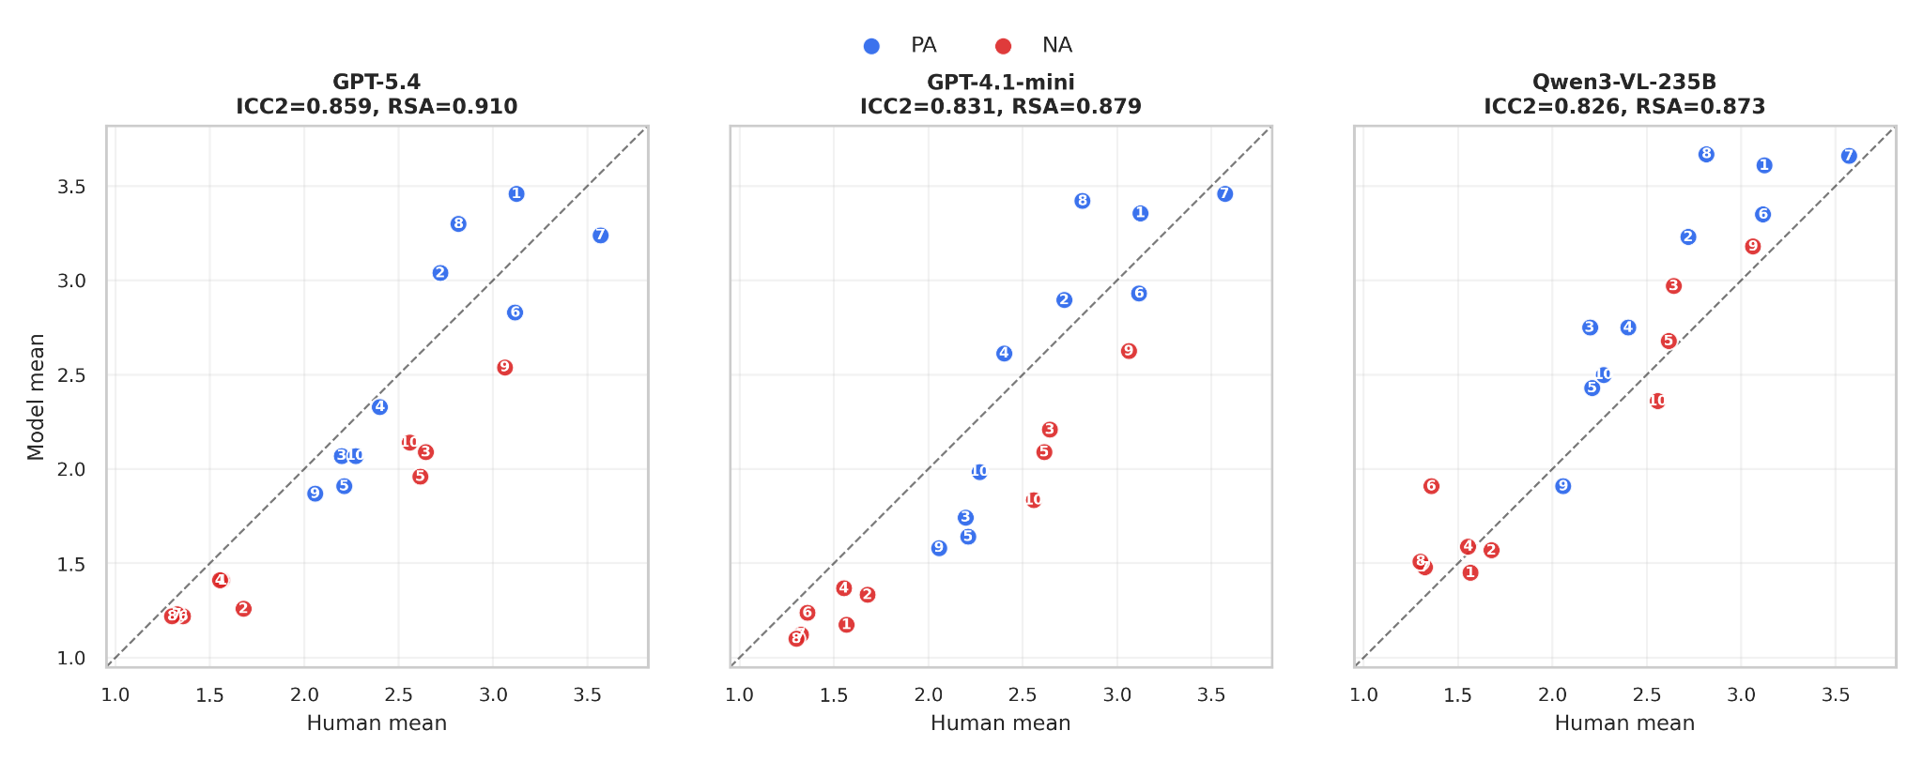
B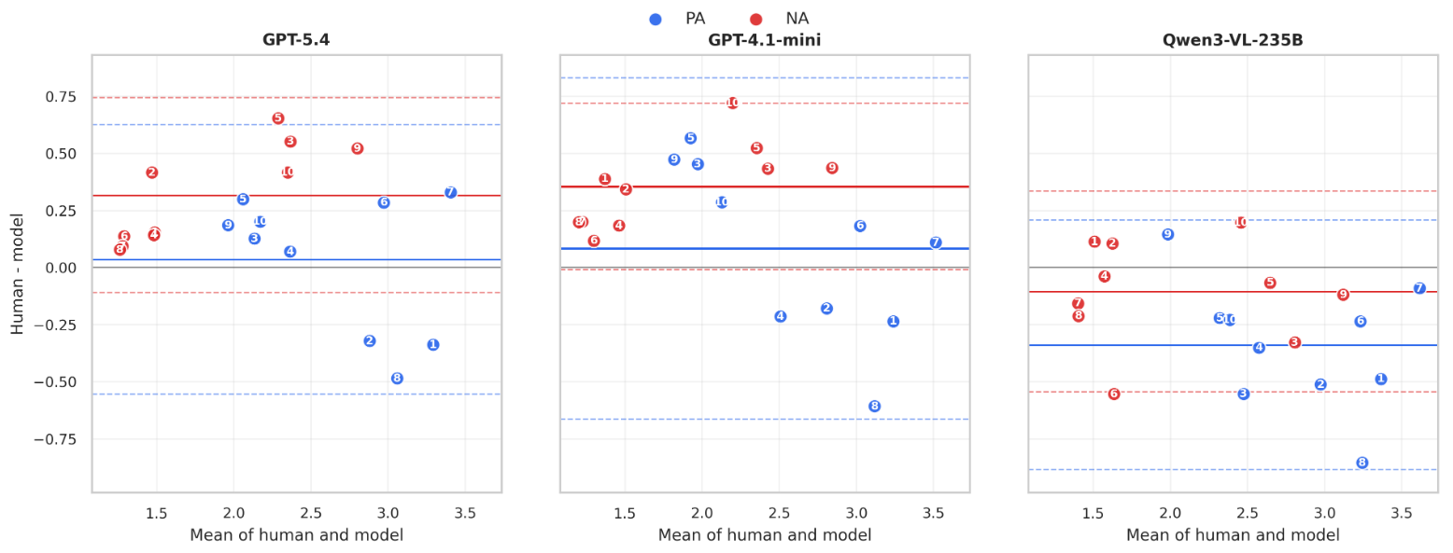
Figure 1. Human-model agreement across image-level PA and NA ratings. (A) Scatter plots comparing human mean ratings with model mean ratings for the three best-performing models. Each point represents one stimulus image, with positive affect (PA) shown in blue and negative affect (NA) shown in red. The dashed identity line indicates perfect agreement between the human and the model. (B) Bland-Altman plots for the same image-level ratings. The x-axis shows the average of the human and model ratings, and the y-axis shows the difference between them, computed as the human mean minus the model mean. Solid horizontal lines indicate the mean difference for each subscale, and dashed lines indicate the corresponding 95% limits of agreement.

Table 1 reports full quantitative agreement statistics for all models, including ICC₂, Spearman correlation, MAE, RMSE, and Bland–Altman-derived bias measures. These results complement the visual patterns shown in Figure 1 by providing a complete model comparison across reliability, ranking consistency, and absolute error.
Across the full model set, agreement was generally strong but varied substantially by model. ICC₂ ranged from 0.46 to 0.86 (median = 0.79), with 13 of 17 models exceeding 0.75 and 8 exceeding 0.80. Models not visualized in Figure 1 but performing near the top included Claude Opus 4.6, LLaMA-4-Scout, GPT-5.2, Claude Haiku 4.5, and Claude Sonnet 4.6. In contrast, GPT-5.4-nano and Gemini 2.5-Flash showed substantially weaker agreement.
Overall, the results indicate that several VLMs robustly reproduce the relative affective structure of human judgments. At the same time, residual differences are primarily attributable to calibration shifts rather than failures in rank-order sensitivity.
Model | ICC₂ | Spearman ρ | MAE (0–1) | RMSE (0–1) | BA mean diff
Claude Haiku 4.5 | 0.808 | 0.817 | 0.106 | 0.136 | −0.092
Claude Sonnet 4.6 | 0.8 | 0.879 | 0.101 | 0.133 | 0.332
Claude Opus 4.6 | 0.823 | 0.885 | 0.094 | 0.124 | 0.284
Gemini 2.5-Flash | 0.464 | 0.657 | 0.202 | 0.252 | 0.57
Gemini 2.5-Pro | 0.735 | 0.844 | 0.131 | 0.164 | 0.403
GPT-4.1 | 0.779 | 0.822 | 0.111 | 0.145 | 0.241
GPT-4.1-mini | 0.831 | 0.869 | 0.097 | 0.125 | 0.22
GPT-4.1-nano | 0.763 | 0.776 | 0.103 | 0.138 | −0.072
GPT-5.2 | 0.82 | 0.859 | 0.088 | 0.116 | 0.187
GPT-5.4 | 0.859 | 0.877 | 0.087 | 0.113 | 0.176
GPT-5.4-mini | 0.791 | 0.801 | 0.101 | 0.135 | 0.178
GPT-5.4-nano | 0.66 | 0.642 | 0.139 | 0.178 | −0.072
LLaMA-3.2-90B-Vision | 0.76 | 0.807 | 0.1 | 0.133 | 0.213
LLaMA-4-Maverick-FP8 | 0.771 | 0.823 | 0.098 | 0.131 | 0.231
LLaMA-4-Maverick-Turbo | 0.747 | 0.801 | 0.101 | 0.137 | 0.238
LLaMA-4-Scout | 0.82 | 0.852 | 0.097 | 0.121 | −0.113
Qwen3-VL-235B | 0.826 | 0.844 | 0.097 | 0.125 | −0.222
Table 1. Quantitative agreement between VLM predictions and human affect ratings across all models. The table reports intraclass correlation (ICC₂) as a measure of absolute agreement, Spearman’s ρ for rank-order consistency, and normalized error metrics (MAE and RMSE on a 0–1 scale) capturing absolute prediction accuracy. The Bland–Altman (BA) mean difference indicates systematic bias (positive values reflect model underestimation relative to human ratings, whereas negative values reflect overestimation).

Representational similarity analysis (RSA) is a method for comparing the internal structures of representations across two systems. Here, it evaluates whether humans and VLMs organize architectural environments into similar affective relationship structures, beyond simple agreement in absolute scores. As demonstrated in Figure 2, VLMs may not precisely reproduce individual emotional ratings, but they often preserve the broader emotional landscape humans perceive across environments.

A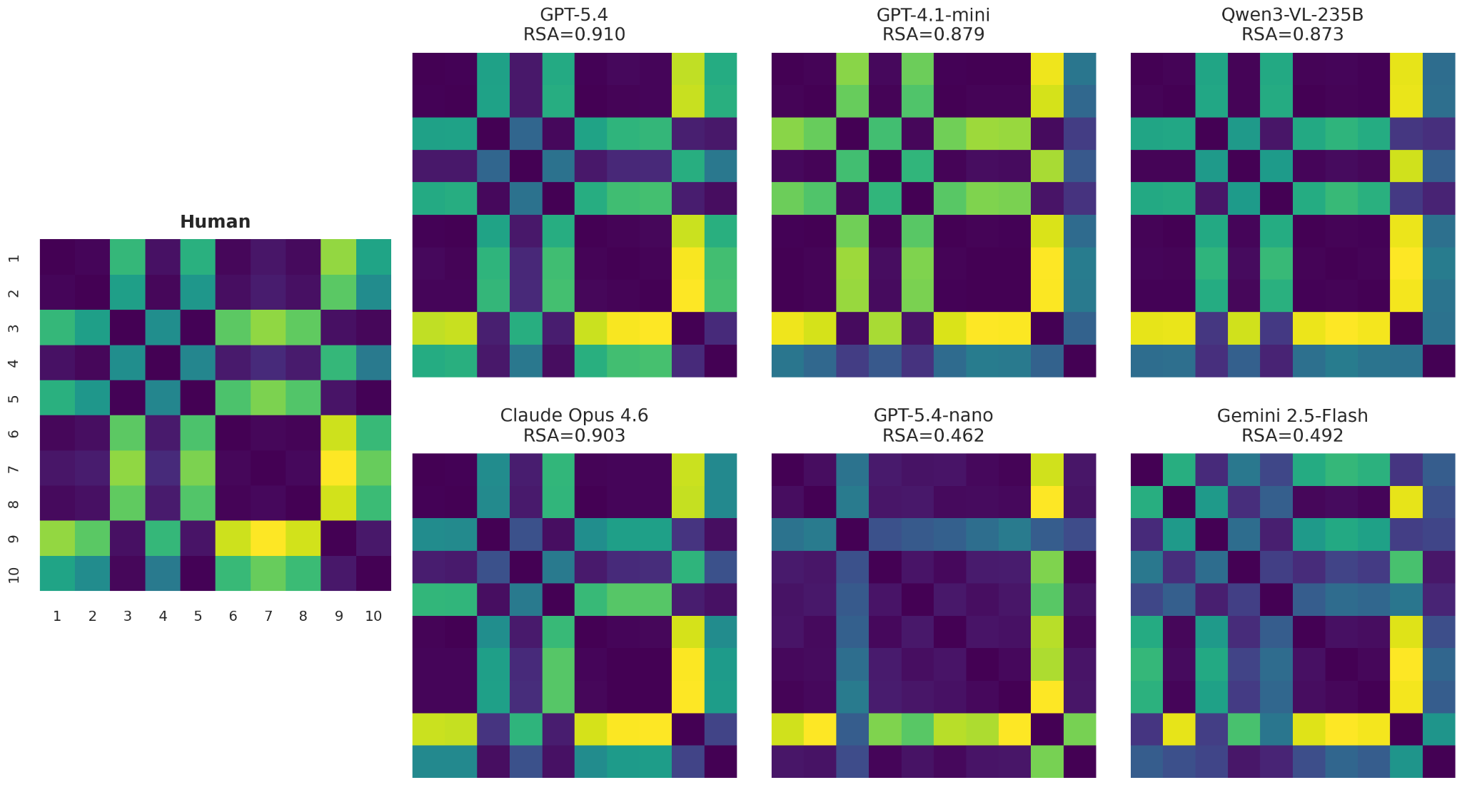 | B  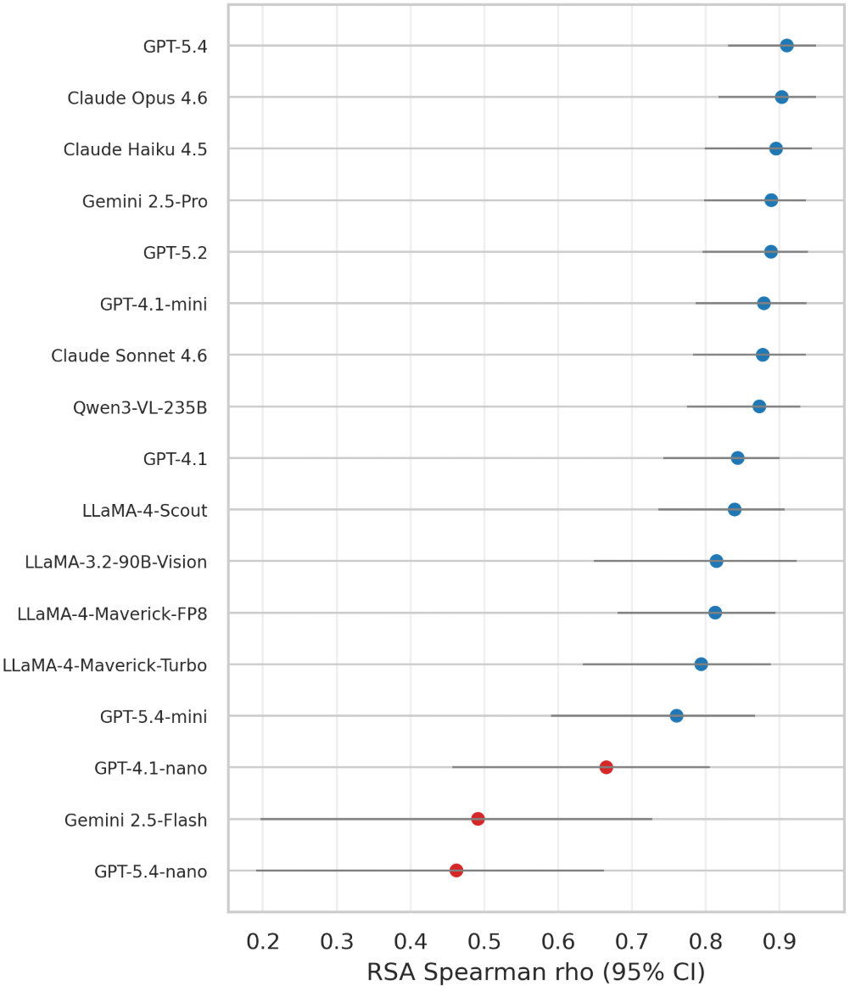
Figure 2. Representational similarity between human and model affective spaces. (A) Representational dissimilarity matrices (RDMs) were computed across stimulus images from PANAS item profiles. The human RDM is shown separately in the left column, with axes labeled by image number. Model RDMs show selected high- and low-performing models, with each panel reporting the Spearman RSA correlation between the model RDM and the human RDM. (B) RSA ranking across all evaluated models. Points indicate RSA Spearman correlations with the human representational geometry, and horizontal lines indicate 95% bootstrap confidence intervals. Red points mark lower-performing models with RSA below 0.70.

Overall, the RSA results suggest that several VLMs capture not only local agreement with human affect ratings but also a partially shared representational geometry of affective perception across architectural environments. Taken together with the agreement, error, and calibration analyses, these findings indicate that model performance should be understood as a multi-level phenomenon: strong models align with humans both in score-level predictions and, to varying degrees, in the underlying structure of affective relationships between environments, whereas weaker models fail first at the level of calibration and only then in representational consistency.

To better understand the sources of error underlying these aggregate performance patterns, we next examine item-level performance across affective descriptors. Figure 3 presents item-level error patterns for the five highest-agreement models, revealing substantial heterogeneity in predictive accuracy across affective descriptors. The lowest errors were observed for jittery (MAE = 0.259), guilty (0.283), strong (0.291), distressed (0.294), and interested (0.304), whereas the highest errors occurred for hostile (0.633), alert (0.521), attentive (0.472), afraid (0.406), and proud (0.405). This pattern indicates that even strong-performing models do not exhibit uniform accuracy across the affective space, but instead show item-specific performance variability.
Aggregating across affect dimensions, positive and negative affect showed comparable absolute accuracy, with slightly lower MAE for NA than PA (PA MAE = 0.395; NA MAE = 0.362). However, signed errors revealed a clear calibration asymmetry: PA was near-unbiased (model − human = +0.043), whereas NA was systematically underestimated (−0.182). Finally, activation-related items exhibited higher error than self-conscious items (0.396 vs. 0.300). However, this difference should be interpreted cautiously, given the low base rates of ashamed and guilty in the human ratings.
This item-level analysis clarifies that high overall model agreement does not imply uniform affective calibration. The dominant errors among top-performing models were not distributed across negative affect as a category, but concentrated in specific high-salience threat and hostility descriptors, particularly hostile and afraid. In contrast, several low-frequency negative items, such as jittery and guilty, showed comparatively low error rates, suggesting that both semantic content and the distributional properties of the rating space influence item difficulty.
The dissociation between absolute error and signed bias is also notable. Although negative affect was not less accurate in MAE terms, it was consistently underestimated, indicating a compression of negative intensity. This pattern suggests that VLMs preserve much of the relative affective structure of environments while attenuating perceived negative valence intensity. For applied use in spatial evaluation, this implies that VLMs may be suitable for comparative assessment of environments, but less reliable for estimating absolute levels of perceived threat, discomfort, or hostility.

A. 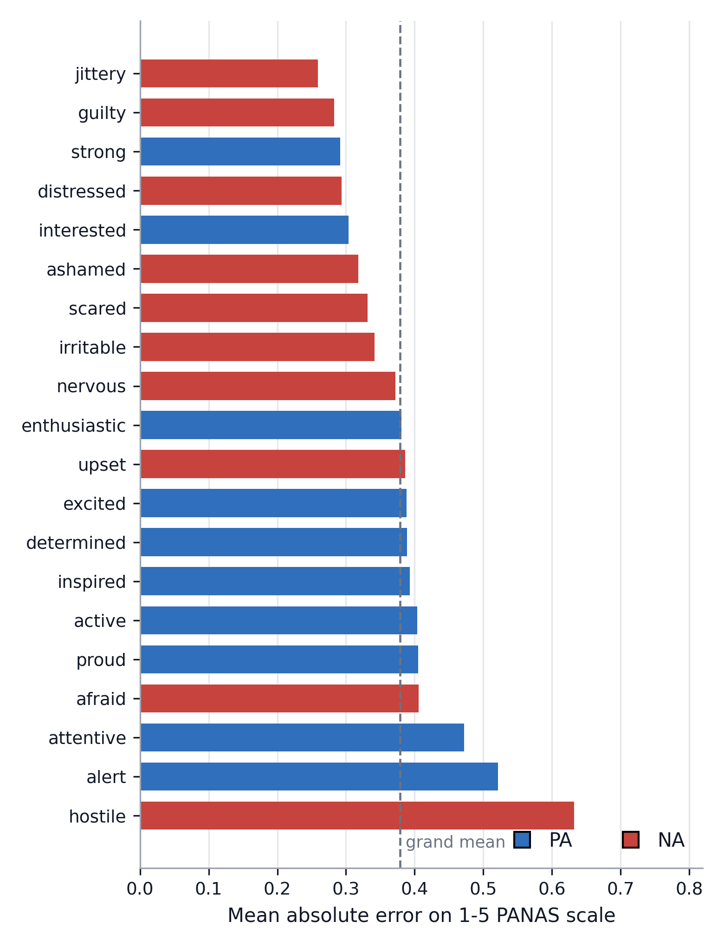 | B.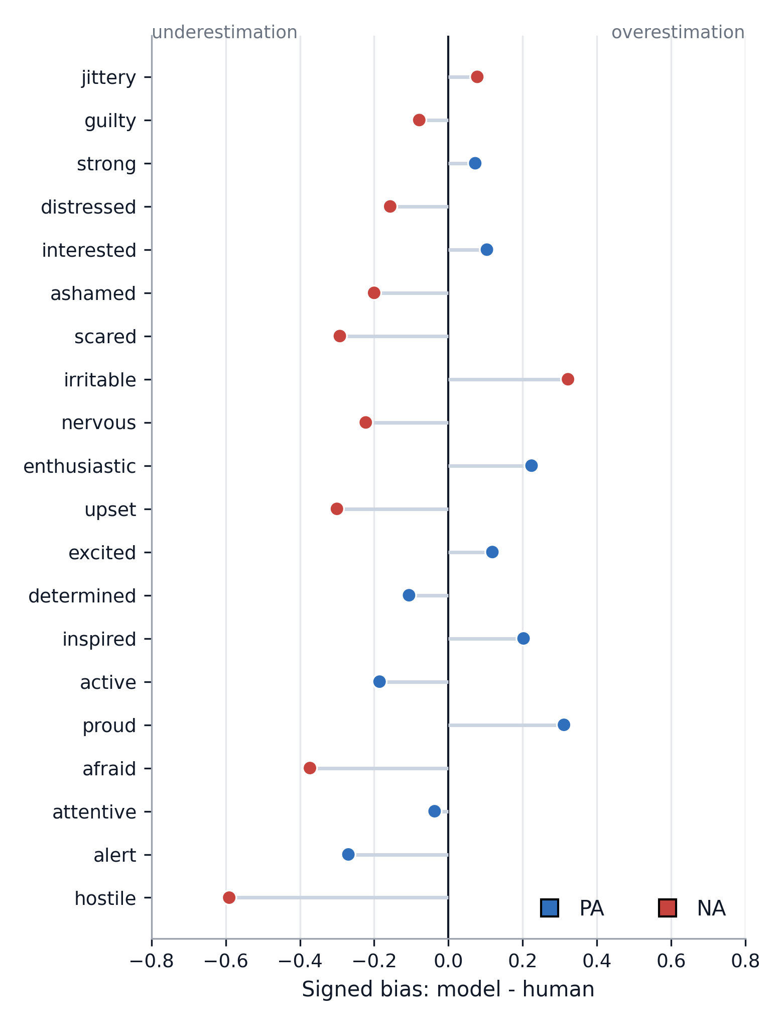
C. 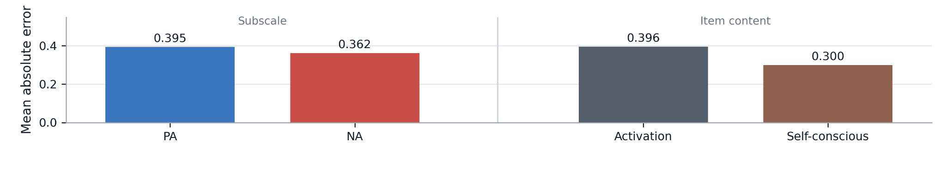
Figure 5. Item-level PANAS error structure among the five highest-agreement VLMs. Item-level errors were computed for the top-performing models based on ICC₂ (GPT-5.4, GPT-4.1-mini, Qwen3-VL-235B, Claude Opus 4.6, and LLaMA-4-Scout). Absolute error was calculated for each image × item pair on the original 1–5 PANAS scale and averaged across models. Blue indicates positive affect (PA) items and red indicates negative affect (NA) items. (A) Item difficulty, showing PANAS descriptors ranked by mean absolute error. (B) Item-level calibration, showing signed bias (model − human mean), where negative values indicate systematic underestimation by VLMs. (C) Planned item-group contrasts comparing PA versus NA items and activation-related (active, excited) versus self-conscious (ashamed, guilty) affect categories.

Discussion and Conclusions
This study evaluated whether contemporary VLMs can serve as proxies for human affective assessment of everyday environments in immersive VR. Using PANAS as a psychometrically grounded measure of positive and negative affect, we compared ratings generated by multiple VLMs with responses from 84 human participants across a curated set of urban environments.
Several models demonstrated substantial agreement with human judgments, achieving strong correspondence in affective ratings, low prediction error, and meaningful similarity in the relational structure of affective representations. These findings extend previous work based on 2D imagery by showing that VLMs can not only approximate aggregate human subjective evaluations of space, but also approximately predict affective human responses within a more ecologically grounded immersive setting. The results suggest that the affective information captured by VLMs is not restricted to conventional image-based assessments, but generalizes to environments experienced through immersive visual exploration.
Taken together, the combined evidence from calibration, representational similarity, and item-level analyses suggests that VLM-human alignment is best characterized as structured but systematically compressed. While high ICC and low error indicate strong correspondence in aggregated affective ratings, the BA and item-level results reveal consistent attenuation of negative affect intensity, particularly for semantically salient descriptors. At the same time, the RSA findings show that despite these calibration distortions, several models preserve the global relational geometry of affective experience across environments. This indicates a dissociation between two levels of alignment: VLMs reproduce the overall structure of the affective space, but compress its local extremities, especially within the negative affect dimension. In practical terms, the models appear capable of identifying which environments are perceived as relatively more positive, negative, calming, or distressing, even when they underestimate the magnitude of these responses. Importantly, such compression may not necessarily represent a limitation for environmental assessment applications. Human affective ratings are inherently variable and influenced by transient factors such as mood, attention, personal experiences, and situational context. Consequently, a model that produces slightly attenuated but structurally consistent predictions may function as a stable estimator of average population-level responses. For applications such as large-scale urban screening, environmental benchmarking, or comparative design evaluation, preserving the relative relationships between environments may be more valuable than reproducing the exact intensity of affective responses. From this perspective, maintaining the global geometry of affective space may constitute one of the most practically useful characteristics of VLM-based assessment.

Implications for Research and Applications
The findings contribute to growing evidence that VLMs can function as computational approximations of aggregate human judgments. While such systems cannot replace direct human evaluation, they may provide a scalable and cost-effective mechanism for estimating likely affective responses in situations where large-scale user studies are impractical.
More broadly, the results suggest a novel approach to affective measurement in the built environment. When the objective is to evaluate environments at the population level, a deterministic assessment tool may offer important advantages. By operating with fixed parameters and producing reproducible outputs, VLMs can generate stable affective estimates for a given environment, reducing the variability associated with repeated human sampling. Such assessments should not be interpreted as direct measurements of individual experience, but rather as standardized estimates of expected collective affective responses. Furthermore, VLMs are not constrained by the discrete response categories available to human participants and can generate continuous-valued estimates of affective responses. This creates the possibility of describing environments in terms of affective performance metrics, enabling comparisons between spaces using a common quantitative framework.
At a research level, this capability opens the possibility of producing large-scale affective maps of cities, neighborhoods, streetscapes, public spaces, and indoor environments. Such maps could complement traditional urban indicators and provide a more nuanced understanding of how the built environment may influence emotional well-being across space.
For designers and planners, VLM-based assessments may provide a systematic complement to professional intuition. Architectural and urban design decisions are often guided by assumptions regarding how users will emotionally respond to a space. Computational affective assessment enables quantitative evaluation of these assumptions during the design process. Because VLMs can rapidly evaluate large numbers of design alternatives, they could also be integrated into iterative design workflows and optimization frameworks. As with contemporary computational design tools, which optimize for factors such as energy performance, daylight availability, accessibility, and cost, future systems may optimize for affective outcomes alongside functional and environmental objectives. This could enable multi-objective design processes in which emotional performance becomes an explicit and measurable design criterion.
An additional advantage of VLM-based evaluation is that models can provide not only numerical ratings but also textual explanations for their judgments. Such explanations help translate affective assessments into actionable design insights and support communication between designers, stakeholders, and clients.

Limitations and Future Research
The present findings should be interpreted in light of several methodological limitations. The results reflect agreement at the aggregated population level rather than at the level of individual emotional experience. Model performance varied across architectures, and the limited number of environments, along with the absence of run-level reliability estimates, highlight the need for further validation on larger, more diverse datasets.
Future work should therefore extend this framework to larger, more diverse datasets, incorporate repeated-measures reliability across prompts and runs, and further investigate how VLM representations of affect generalize across spatial contexts and perceptual conditions. Future research should also investigate whether VLMs can be adapted to represent specific demographic or cultural populations. Emotional responses to environments vary across groups, and conditioning model outputs on demographic, cultural, or contextual information may improve predictive accuracy. At the same time, such investigations may help identify biases embedded within model training data, an important prerequisite for the responsible deployment of VLM-based affective assessment tools.
Overall, the findings suggest that VLMs may serve as useful tools for scalable exploratory affective assessment in the built environment. Rather than replacing human evaluation, such systems may provide a complementary mechanism for rapidly identifying environments likely to elicit positive or negative affective responses, thereby supporting data-informed design and planning processes. Their ability to generate reproducible, interpretable, and spatially scalable affective evaluations opens new opportunities for environmental research, urban analytics, and evidence-informed design. As these technologies continue to improve, they may provide a foundation for integrating human-centered affective considerations into computational design and planning workflows at unprecedented scales.

Declaration of generative AI and AI-assisted technologies in the manuscript preparation process: During the preparation of this work the authors used Claude and ChatGPT to assist with data analysis and language editing. After using this service, the authors reviewed and edited the content as needed and take full responsibility for the content of the published article.

References
Aghabozorgi, K., van der Jagt, A., Bell, S., & Smith, H. (2024). How university blue and green space affect students’ mental health: A scoping review. Urban Forestry & Urban Greening, 97, 128394.
Al Alam, R. T., & Dibben, N. (2021, March). A comparison of presence and emotion between immersive virtual reality and desktop displays for musical multimedia. In Future Directions of Music Cognition 2021 Virtual Conference Proceedings. Ohio State University Libraries.
Amin, M. M., Cambria, E., & Schuller, B. W. (2023). Will affective computing emerge from foundation models and general artificial intelligence? A first evaluation of ChatGPT. IEEE Intelligent Systems, 38(2), 15–23.
Argyle, L. P., Busby, E. C., Fulda, N., Gubler, J. R., Rytting, C., & Wingate, D. (2023). Out of one, many: Using language models to simulate human samples. Political Analysis, 31(3), 337–351.
Bommasani, R., Hudson, D. A., Adeli, E., Altman, R., Arora, S., von Arx, S., ... & Liang, P. (2021). On the opportunities and risks of foundation models. arXiv preprint arXiv:2108.07258.
Chirico, A., Cipresso, P., Yaden, D. B., Biassoni, F., Riva, G., & Gaggioli, A. (2017). Effectiveness of immersive videos in inducing awe: An experimental study. Scientific Reports, 7(1), 1218.
Dores, A. R., Barbosa, F., Monteiro, L., Leitão, M., Reis, M., Coelho, C. M., ... & Castro-Caldas, A. (2014). Amygdala activation in response to 2D and 3D emotion-inducing stimuli.
Guz, G., Martelaro, N., Schubert, G., & Dortheimer, J. (2025). Quantifying architectural experience using visual language models: Does AI dream of rendered spaces? In CAAD Futures 2025 – Catalytic Interfaces: Conference Proceedings (Vol. 1, pp. 467–482). University of Hong Kong.
He, N., & Li, G. (2021). Urban neighbourhood environment assessment based on street view image processing: A review of research trends. Environmental Challenges, 4, 100090.
Jiang, H., Zhang, X., Cao, X., Breazeal, C., Roy, D., & Kabbara, J. (2024, June). PersonaLLM: Investigating the ability of large language models to express personality traits. In Findings of the Association for Computational Linguistics: NAACL 2024 (pp. 3605–3627).
Kuhne, C., Kecelioglu, E. D., Maltby, S., Hood, R. J., Knott, B., Ditton, E., ... & Kluge, M. G. (2023). Direct comparison of virtual reality and 2D delivery on sense of presence, emotional and physiological outcome measures. Frontiers in Virtual Reality, 4, 1211001.
Ma, H., Zhang, Y., Liu, P., Zhang, F., & Zhu, P. (2024). How does spatial structure affect psychological restoration? A method based on graph neural networks and street view imagery. Landscape and Urban Planning, 251, 105171.
Ogawa, Y., Oki, T., Zhao, C., Sekimoto, Y., & Shimizu, C. (2024). Evaluating the subjective perceptions of streetscapes using street-view images. Landscape and Urban Planning, 247, 105073.
Qin, B., Zhu, W., Wang, J., & Peng, Y. (2021). Understanding the relationship between neighbourhood green space and mental wellbeing: A case study of Beijing, China. Cities, 109, 103039.
Rui, J., & Cai, C. (2025). Plausible or misleading? Evaluating the adaption of the Place Pulse 2.0 dataset for predicting subjective perception in Chinese urban landscapes. Habitat International, 157, 103333.
Salesses, P., Schechtner, K., & Hidalgo, C. A. (2013). The collaborative image of the city: Mapping the inequality of urban perception. PLOS ONE, 8(7), e68400.
Schubring, D., Kraus, M., Stolz, C., Weiler, N., Keim, D. A., & Schupp, H. (2020). Virtual reality potentiates emotion and task effects of alpha/beta brain oscillations. Brain Sciences, 10(8), 537.
Scott, K. E., & Benson, J. F. (2002). Public and professional attitudes to landscape: Scoping study.
Tian, F., Hua, M., Zhang, W., Li, Y., & Yang, X. (2021). Emotional arousal in 2D versus 3D virtual reality environments. PLOS ONE, 16(9), e0256211.
Van Der Wal, J. M., Van Borkulo, C. D., Deserno, M. K., Breedvelt, J. J., Lees, M., Lokman, J. C., ... & Wiers, R. W. (2021). Advancing urban mental health research: From complexity science to actionable targets for intervention. The Lancet Psychiatry, 8(11), 991–1000.
Watson, D., Clark, L. A., & Tellegen, A. (1988). Development and validation of brief measures of positive and negative affect: The PANAS scales. Journal of Personality and Social Psychology, 54(6), 1063.
Weinreb, A. R., & Rofè, Y. (2013). Mapping feeling: An approach to the study of emotional response to the built environment and landscape. Journal of architectural and planning research, 127-145.
Xie, J., Lan, P., Wang, S., Luo, Y., & Liu, G. (2022). Brain activation differences of six basic emotions between 2D screen and virtual reality modalities. IEEE Transactions on Neural Systems and Rehabilitation Engineering, 31, 700–709.
Zhao, X., Lu, Y., & Lin, G. (2024). An integrated deep learning approach for assessing the visual qualities of built environments utilizing street view images. Engineering Applications of Artificial Intelligence, 130, 107805.

